Child Protection - Policies and Procedures:

Peter’s Patch complies with the procedures approved by the Area Child Protection Committee. We intend to create in our nursery an environment in which children are safe from abuse and in which any suspicion of abuse is promptly and appropriately responded to.

In order to achieve this, we will:

Exclude known abusers

All applicants for work within the nursery, whether voluntary or paid, will be interviewed before an appointment is made and will be asked to provide at least two references and have a police check before coming into work.

All such references will be followed up

In the case of applicants with unexplained gaps in their employment history, or who have moved rapidly from one job to another, explanations will be sought.

All appointments, both paid and voluntary, will be subject to a probationary period and will not be confirmed unless the nursery is confident that the applicant can be safely entrusted with children.

Seek and supply training

We will seek out training opportunities for all adults involved in the group to ensure that they recognise the symptoms of possible physical abuse, neglect, emotional abuse and sexual abuse.
Prevent abuse by means of good practice.

Adults who are not employed by the nursery, e.g. students, will not take children unaccompanied to the toilet.

The layout of the playroom will permit constant supervision of all children.

Keep records

Whenever worrying changes are observed in a child’s behaviour, physical condition or appearance, a specific and confidential record will be set up, separate from the usual on-going records of children’s progress and development.

The record will include, in addition to the name, address and age of the child: timed and dated observations, describing objectively the child’s behaviour/appearance, without comment or interpretation:

Peter’s Patch will where possible, record the exact words spoken by the child; the dated name and signature of the recorder. Such records will be kept in a separate file and will not be accessible to people other than nursery management.

Liaise with other bodies

The nursery operates in accordance with guidelines laid down by the Registering authority. Confidential records kept on children about whom the nursery is anxious will be shared with Social Services. We will pass on concerns without judgement on what is adequate and inadequate in explanation and if in doubt-pass on also. The group will maintain ongoing contact with the registering authority, together with names, addresses and telephone numbers of individual social workers, to ensure that it would be easy, in any emergency, for the nursery and the Social Services Department to work well together. Records will also be kept of the local N.S.P.C.C. contact, or other contact(s) as appropriate.

Support families

The nursery will take every step in its power to build up trusting and supportive relationships between families and staff and volunteers in the group. Where a child protection issue is suspected, the nursery will continue to welcome the child and family while investigations proceed.

We will-
- Ensure all our staff/ students have undergone the appropriate background checks.
- Ensure all our staff are familiar with child protection procedures and have a clear understanding of the action which must be taken where abuse or neglect are suspected.
- Make sure all staff have undergone appropriate training and are familiar with various signs and symptoms of abuse.
- Provide up to date training.
- Ensure all children are collected only by those adults listed in our records.
- Provide a safe and secure environment through appropriate security systems.
- Provide activities which will help children acquire the skills and confidence needed to protect them.

Staff in Peter’s Patch will not ignore any child protection issues, the children’s needs and welfare are paramount, and therefore it is imperative that we care, protect and act when necessary.

Physical abuse

Physical abuse is any intentional act causing injury or trauma to another person by way of bodily contact

Types of Physical Abuse

- Hitting
- Kicking
- Shaking
- Throwing
- Poisoning
- Burning
- Scalding
- Drowning

- Any other method of causing non accidental harm to a child

Recognising Physical Abuse

- Bruises
- Burns or scalds
- Bite marks
- Fractures or broken bones
- Behavioural changes

Signs of Head Injury in an infant:

- Swelling bruising or fractures
- Unusual behaviour – lethargic, irritable, unresponsive, or not wanting to feed
- Seizures
- Vomiting
- Respiratory problems
- Being comatose

Sexual Abuse

Types of Sexual Abuse

Contact (when an abuser makes a physical contact with a child):
- Sexual touching of any part of the body, whether the child is wearing clothes or not
- Forcing or encouraging a child to take part in sexual activity
- Making a child take their clothes off or touch someone else’s genitals
- Rape or penetration by putting an object or body part inside a child’s mouth, vagina or anus
Non-contact (involves activities where there is no physical contact):
- Flashing at a child
- Encouraging or forcing a child to watch or hear sexual acts
- Not taking proper measures to prevent a child being exposed to sexual activities by others
- Making a child masturbate while other watch
- Persuading a child to make, view or distribute child abuse images
- Making, viewing or distributing child abuse images
- Allowing someone else to make, view or distribute child abuse images
- Meeting a child following grooming with the intent of abusing them, even if the abuse did not take place
- Sexually exploiting a child for money, power or status (child sexual exploitation)

Signs and Indicators

Physical

- Bruising
- Bleeding
- Discharge
- Pain or soreness in genital / anal area
- Sexually transmitted infections
- Pregnancy at a young age can also be in an indicator of sexual abuse

Emotional and behavioural
- Being afraid of or avoiding a particular person including a family member or friend
- Having nightmares or bed wetting
- Being withdrawn
- Alluding to ‘secrets’
- Self-harming
- Running away from home
- Developing eating problems
- Displaying sexualised behaviour or having sexual knowledge which is inappropriate for their stage of development
- Misusing drugs or alcohol

Domestic and Sexual Violence and Abuse
The Stopping Domestic and Sexual Violence and Abuse in Northern Ireland Seven Year Strategy (2016) defines domestic and sexual violence and abuse as follows:
Domestic Violence and Abuse:
‘threatening, controlling, coercive behaviour, violence or abuse (psychological, virtual, physical, verbal, sexual, financial or emotional) incited on anyone irrespective of age, ethnicity, religion, gender identity, sexual orientation or any form of disability by a current or former intimate partner or family member’.
Sexual Violence and Abuse:
‘any behaviour (physical, psychological, verbal, virtual/online) perceived to be of a sexual nature which is controlling, coercive, exploitive, harmful, or unwanted that is incited on anyone (irrespective of age, ethnicity, religion, gender, gender identity, sexual orientation or any form of disability)’

Types of Domestic Abuse
Domestic abuse is any type of controlling, bullying, threatening or violent behaviour between people in a relationship. It can seriously harm children and young people and witnessing domestic abuse is Child Abuse. It’s important to remember domestic abuse:
- Can happen inside or outside the home
- Can happen over the phone, on the internet and on social networking sites
- Can happen in any relationship and can continue even after the relationship has ended
- Both men and women can be abused or abusers

Signs of Domestic Abuse
It can be difficult to tell if domestic abuse is happening and those carrying out the abuse can act very differently when other people are around. Children and young people might also feel frightened and confused, keeping the abuse to themselves.
Signs that a child has witnessed domestic abuse can include:
- Aggression or bullying
- Anti-social behaviour, e.g. vandalism
- Anxiety, depression or suicidal thoughts
- Attention seeking
- Bed-wetting, nightmares or insomnia
- Constant or regular sickness, like colds, headaches and mouth ulcers
- Eating disorders
- Problems in school or trouble learning
- Tantrums
- Withdrawal
- Drug or alcohol use (older children)
Our priority is to ensure the abuse stops and that children have a safe and stable environment to grow up in.

Safeguarding procedures relating to Domestic Abuse
- Listen carefully to what the child is saying. Ask open ended questions
- Let them know they’ve done the right thing by telling you
- Tell them it’s not their fault
- Say you’ll take them seriously
- Do not confront the alleged abuser
- Explain what you will do next
- Record and report what the child has told you as soon as possible to the Designated Child Protection Officer and to Gateway Team

Psychological and emotional abuse
Some level of emotional abuse is present in all types of abuse or neglect, though it may also appear alone. It is the persistent mistreatment of a child that has a severe and negative impact on their emotional development. Emotional abuse may also be perpetrated by other young people through serious bullying and cyber-bullying.
- Overprotection – preventing someone accessing educational and social opportunities and seeing friends
- Intimidation, coercion, harassment, use of threats, humiliation, bullying, swearing or verbal abuse
- Conveying feeling of worthlessness, inadequacy or that a child is unloved
- Threats of harm or abandonment
- Placing inappropriate expectations on children
- Witnessing or hearing the abuse or ill-treatment of others (including domestic violence)

Possible indicators of emotional abuse;
- Concerning interactions between parents or carers and the child (e.g. overly critical or lack of affection)
- Lack of self-confidence or self-esteem
- Sudden speech disorders
- Self-harm or eating disorders
- Lack of empathy shown to others (including cruelty to animals)
- Drug, alcohol or other substance misuse
- Change of appetite, weight loss/gain
- Signs of distress: tearfulness, anger

Neglect
Types of neglect
Neglect is found to be a factor in 60 per cent of child deaths that are investigated through Serious Case Reviews. However, even though it is often suspected by those who work with children, it is under-reported. Neglect is a persistent failure to meet basic needs (physical or emotional) and it leads to serious harm to the health or development of a child.
- Failing to provide adequate shelter, clothing or food
- Failing to protect a child from harm or danger
- Failing to ensure that a child is supervised appropriately
- Failing to access medical care or treatment for a child when it is needed.
Possible indicators of neglect;
- Excessive hunger
- Inadequate or insufficient clothing
- Poor personal or dental hygiene
- Untreated medical issues
- Changes in weight or being excessively under or overweight
- Low self-esteem, attachment issues, depression or self-harm
- Poor relationships with peers
- Self-soothing behaviours that may not be age-appropriate (e.g. rocking, hair-twisting, thumb-sucking)

Peter’s Patch will keep improving practice by;
- Keeping records of discussions and meetings and build a chronology that can help to identify parenting capacity over time
- Don’t accept presenting behaviour as fact: seek evidence to make sure that you get a balanced view of what is happening
- Challenge the views of staff: being overly optimistic of what parents can achieve means that support is offered too late
- Be child-focused: keep the child at the centre of planning and information gathering and always seek and record their perspectives

A parent’s or carer’s behaviour can make it difficult for us to recognise abuse or neglect at an early enough stage or delay reporting it.

Disguised compliance involves care-givers presenting an appearance of being co-operative and supportive in order to avoid scrutiny, suspicion or concern.

These behaviours may include;

- Doing ‘just enough’
- Hard to engage
- Being critical of other professionals
- Giving accounts that are different to a child’s
- Dominating discussions
- Misdirecting

Bullying
This is the repeated verbal, physical, social or psychological aggressive behaviour that can be caused by one person, or a group of people to a less powerful person or group of people.

The signs and symptoms include;
- Withdrawal.
- Reluctance to be with certain individuals.
- Unexplained injuries.
- Loss of valuables.
- Aggressive towards others.
- Being afraid to voice opinion.
- Lowering of confidence and self-esteem.
- Tearfulness.
Bullying can occur by other children, or by adults.

Discriminatory abuse
This occurs when individuals are not treated equally in line with legislation, their values, beliefs and cultures are ignored.
Signs and symptoms are:
- Poor care and support that does not meet the individual’s needs.
- Verbal abuse.
- Disrespect towards the individual.
- Exclusion from activities and services.

Fabricated or induced illness
This form of child abuse is quite rare, however it is still serious, it occurs when a parent or carer (often it is most likely the child’s biological mother) exaggerates or deliberately causes the symptoms of illness in the child.
Signs and symptoms include:
- The child’s parent/s attempting to persuade healthcare professionals that their child is ill when it is evident that they are perfectly healthy.
- Lying or exaggerating symptom’s.
- Manipulating test results – such as putting sugar into the child’s urine test to suggest that they have diabetes.
- Deliberately inducing symptoms, such as poisoning a child.

Female Genital Mutilation (FGM)
FGM is the partial or total removal of female genitalia, through cutting, injuring or changing when there is no medical reason to do so.
It is usually carried out on young girls between infancy and the age of 15, most commonly before the onset of puberty. It is illegal in the UK.
Signs and symptoms include;
- Difficulties with urination.
- Constant pain.
- Incontinence.
- Frequent vaginal, pelvic or urinary infections.
- Menstrual problems.
- Discomfort when sitting or standing.
- Appearing anxious and depressed.
- Reluctant to undergo medical examinations.
- Unusual absence from school or college.

Modern slavery
This type of abuse includes slavery, sex trafficking and forced labour.
The signs and symptoms include;
- Signs of physical and emotional abuse.
- Rarely allowed to travel alone.
- Appearing to be under the control of someone else.
- Few or no personal belongings.
- Hesitation when speaking with strangers.
- Not being registered with a school or a GP practice.
- Reluctant or can’t share personal information or where they live.
- Orphaned or living apart from their family.

Child Exploitation & Neglect
Child sexual exploitation is a form of child sexual abuse. It occurs where an individual or group takes advantage of an imbalance of power to coerce, manipulate or deceive a child into sexual activity (a) in exchange for something the victim needs or wants, and/or (b) for the financial advantage or increased status of the perpetrator or facilitator. Child sexual exploitation does not always involve physical contact; it can also occur through the use of technology.
Indicators include:
Inappropriate sexual behaviour.
Evidence of/suspicions of physical or sexual assault.
What to do if a child makes a disclosure
Listen.
Make no promises.
No leading questions.
Staff are never on their own.
Report to a Child Protection Officer Immediately!

Bruising on Pre-Mobile Babies (For more information see separate policy)
“Definition: A pre-mobile baby is a baby who is not yet crawling, not actively
rolling as a means of mobility (including those only able to flip from back to
front), not bottom shuffling, not pulling to stand, not cruising nor walking
independently”.
Key Messages:
1. Bruising is the most common presenting feature of physical abuse in children.
2. Bruising/marks (which could be due to injury) should prompt suspicion of maltreatment.
3. Bruising/marks (which could be due to injury) on any pre-mobile baby should prompt an immediate referral to a senior paediatrician for urgent medical assessment and enquiry to social services.
4. Bruising/marks (which could be due to injury) assessed as having no accidental explanation consistent with the clinical findings must be referred to children’s social services for investigation.
In pre-mobile babies for whom the nature of the bruise/mark clearly suggests physical abuse from the outset SBNI Regional Core Policies and Procedures http://www.proceduresonline.com/sbni/ must be initiated with immediate telephone referral to children’s social services and completion of a UNOCINI referral form (unless children’s social services direct otherwise) within 24 hours.
Identification and Referral under this protocol: Any bruise/mark (which could be due to injury) on a pre-mobile baby observed by a health or social care professional which cannot be explained by previous treatment and care provided by health professionals1 should raise suspicion of maltreatment and be referred to a senior paediatrician for urgent medical assessment.
It is the responsibility of the first professional who learns of (or identifies) the bruise/mark (which could be due to injury) to make the referral by telephone to the senior paediatrician. This telephone referral should be followed up in writing and forwarded to the senior paediatrician immediately (by e-mail if possible, which should be password protected), in accordance with local arrangements. A suggested referral form for hospital paediatric assessment is available (see below).
Consent for referral for Paediatric Assessment: Families and professionals should work in partnership. If a person with parental responsibility refuses consent for paediatric assessment, advice must be sought immediately from direct line managers in terms of how to progress. If necessary, SBNI Core Regional Policies and Procedures should be initiated.
NB: Previous treatment or care provided by health professionals includes bruising/marks arising from birth trauma.
Useful contact numbers for parents and children
National Domestic Violence Helpline 08088021414
Childline 0800 1111

Gateway team 0300 1000 300
Early Years Team: 028 4451 3807

Reporting concerns-

Concerns about possible abuse are reported to our Designated Officers Natasha Ferson, Nicola Gregory, Lyn Sloan, Melissa McKee, Lydia Glendinning, Amy Cousins and Joanne Ireland in turn they will follow the procedures and inform social services.

If a child makes a disclosure to a member of staff or a member of staff has concerns about suspected child abuse, they must act promptly, staff should not investigate, this is a matter for Social Services. Instead, record fully all details as accurate as possible everything they have been told, heard and seen stating facts not opinions, contact one of the designated officers immediately who will carry out the correct procedures.

This will involve contacting Gateway or Out if Hours immediately to report the situation. Gateway should also be contacted in the event that DCPO’s are unsure how to proceed in a situation. They will offer support and guidance throughout.

If the reporting staff member feels that the DCPO is not responding in an appropriate way, they should contact Gateway directly.

The Early Years Team should be kept up to date on the situation, after Gateway has been contacted.

This information should never be disclosed to another of member of staff, it must always be treated with full confidentiality and only people who need to know will know.

Operation Encompass-
If Police attend a domestic abuse call, and children are present, Operation Encompass allows the officers to pass on relevant information to the safeguarding team at the child's school before 9am the following morning, so the right support can be put in place.

Does Operation Encompass replace safeguarding?
This protocol DOES NOT replace or supersede existing protocols, or singularly address child welfare. The protocol should always be followed in conjunction with the current safeguarding procedures and is designed to reinforce safeguarding and ensure children's wellbeing support after a domestic incident.

Complaints about staff-

If there is a complaint made about suspected child abuse against a member of staff, the procedure listed above will apply. This should be reported immediately, however if the complaint is about one of the designated persons, the concerns should be made to the other designated person who will carry out the procedure outlined.

Where a matter is referred to social services the member of staff may be subject to precautionary measures i.e. pending an investigation by social services.

Please note that information given to members of staff about possible child abuse cannot be held in confidence, to ensure the safety of the child, staff have an
obligation morally and legally to share this information with other professionals. Information is kept in a safe secure place.

In all aspects of Child Protection, it is essential that Parents, Staff and Outside Agencies work together for the good of the child. Each has a responsibility to keep the others informed of any changes, concerns or incidents which may occur.
We ask that Parents keep the nursery up to date regarding any additional support their child or family is receiving in order for us to ensure that information is shared correctly, and adequate support is given throughout. This information will be shared in the setting on a need-to-know basis.
Our Designated Child Protection Officers are:
Natasha Ferson, Nicola Gregory, Melissa McKee,
Lydia Glendinning, Lyn Sloan, Amy Cousins
and Joanne Ireland
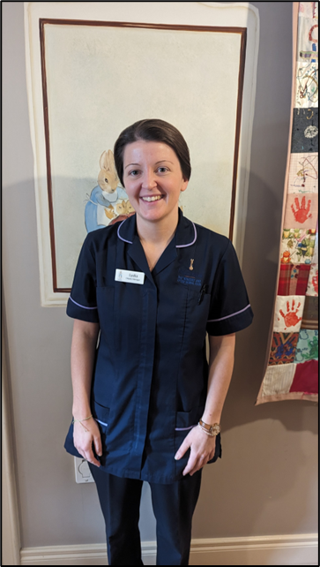
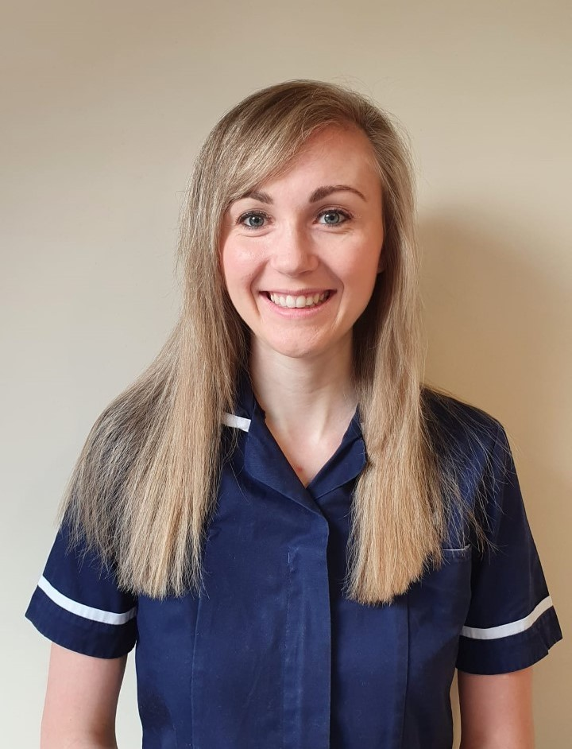

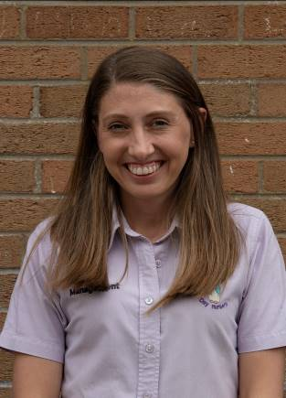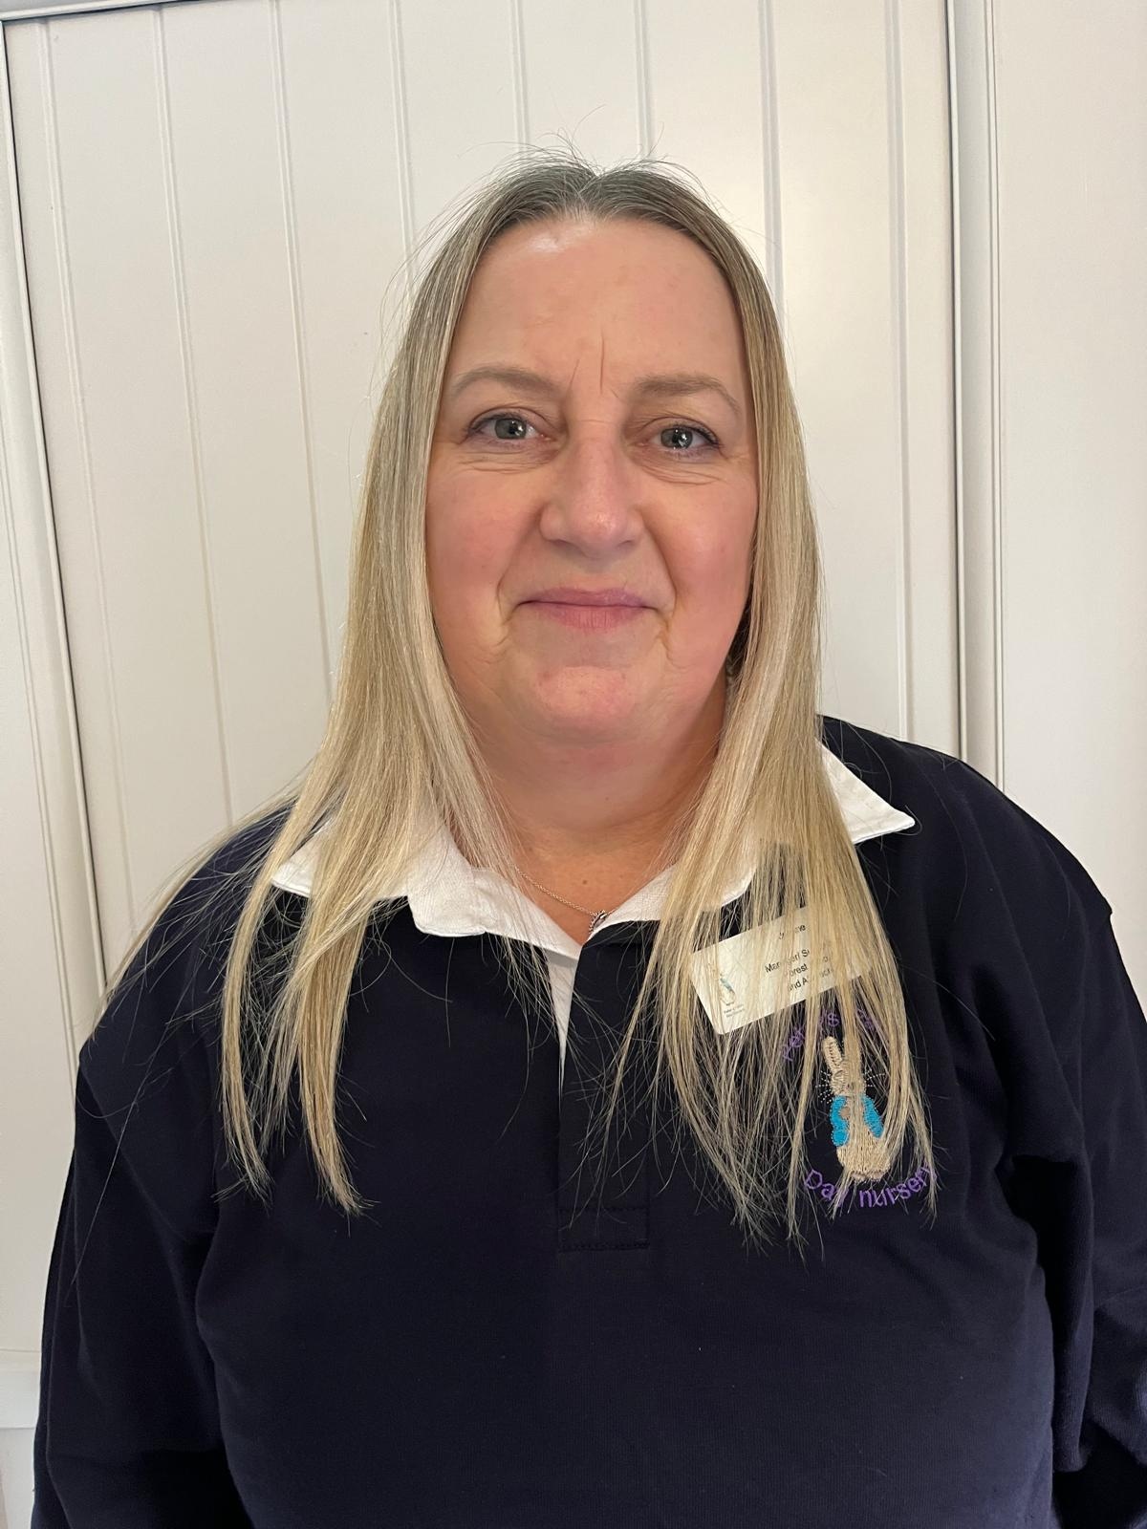

Contact on – 02892 688005
Or
Peters-patchdaynursery@live.co.uk

The procedure for reporting a suspected Child Protection concern.
Room Supervisor

Child Protection officer

Gateway team 0300 1000 300
Useful contact numbers-
Designated officers - Natasha, Nicola, Melissa, Lydia, Lyn, Amy, Joanne - 02892 688005
Gateway team 0300 1000 300
Out of hours – Please contact Northern Ireland Health and Social Care (HSC) trusts Gateway Services for Children’s Social work emergency out of hours – 02895049999.
Early Year’s Team- Lynsey Foster - 02844 513807 P.S.N.I. – 101
Updated: 22/01/2025

